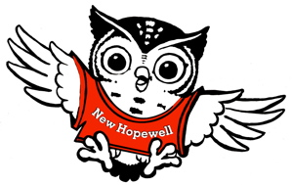

**Second Grade Supply List**

**2025 - 2026**

2 sets of headphones

2 boxes of #2 pencils

2 boxes of 24 crayons

1 package of colored markers

1 pair of scissors

1 ruler (inches/centimeters)

2 packs of glue sticks

4 Plastic folders with prongs

(Blue, Green, Purple, Yellow)

1 packages of dry erase markers

3 packages of Tissues

1 pack of Post It notes

2 package of cap erasers

1 large pencil box

Hand sanitizer

Wish list

Girls: 1 pack of baby wipes

Boys: Notebook paper (1 pack – wide ruled)